**Week – 13**

Implement the classic problem of synchronization using semaphore and monitor

**Code: (Basic Thread)**

#include<stdio.h>  
#include<unistd.h>  
#include<stdlib.h>  
#include<string.h>  
#include<pthread.h>  
  
void *thread_function(void *arg);  
char message[] = "Hello world!";  
  
int main(){  
    int res;  
    pthread_t a_thread;  
    void *thread_result;  
    res = pthread_create(&a_thread,NULL,thread_function,(void *)message);  
    if(res != 0){  
        perror("Thread creation failed");  
        exit(EXIT_FAILURE);  
    }  
    printf("Waiting for thread to finish...\n");  
    res = pthread_join(a_thread,&thread_result);  
    if(res != 0){  
        perror("Thread join failed");  
        exit(EXIT_FAILURE);  
    }  
    printf("Thread joined, it returned %S\n",(char *)thread_result);  
    printf("Message is now %s\n",message);  
    exit(EXIT_SUCCESS);  
    }  
void *thread_function(void *arg){  
        printf("thread_function is running.Argument was %s\n",(char *)arg);  
        sleep(3);  
        strcpy(message,"Bye!");  
}

**Output:**

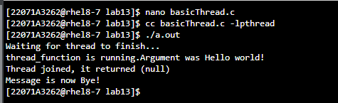

**Code (Producer & Consumer - 1)**

#include <stdio.h>

#include <pthread.h>

#include <semaphore.h>

#define SHARED 1

void *Producer();

void *Consumer();

sem_t empty, full, sm;

int data;

int main() {

pthread_t ptid, ctid;

printf("\nMain Started");

sem_init(&empty, SHARED, 1);

sem_init(&full, SHARED, 0);

sem_init(&sm, SHARED, 1);

pthread_create(&ptid, NULL, Producer, NULL);

pthread_create(&ctid, NULL, Consumer, NULL);

pthread_join(ptid, NULL);

pthread_join(ctid, NULL);

printf("\nMain done\n");

return 0;

}

void *Producer() {

int produced;

printf("\nProducer created");

for (produced = 0; produced < 100; produced++) {

sem_wait(&empty);

sem_wait(&sm);

data = produced;

sem_post(&sm);

sem_post(&full);

printf("\nProducer: %d", data);

}

return NULL;

}

void *Consumer() {

int consumed, total = 0;

printf("\nConsumer created");

for (consumed = 0; consumed < 100; consumed++) {

sem_wait(&full);

sem_wait(&sm);

total += data;

sem_post(&sm);

sem_post(&empty);

printf("\nConsumed: %d", data);

}

printf("\nThe Total of 100 iterations is %d\n", total);

return NULL;

}

**Output:**

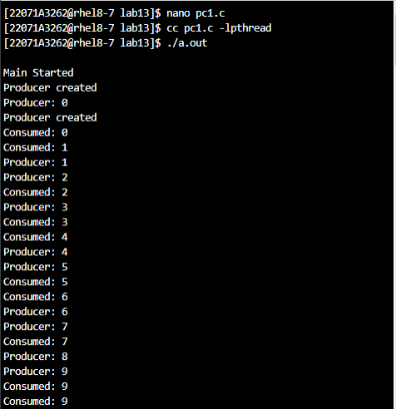

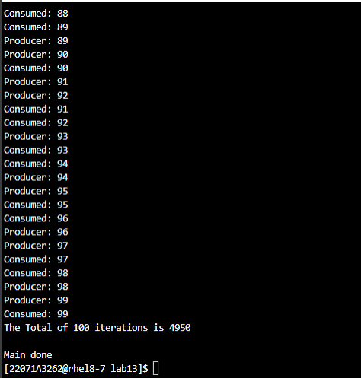

**Code (Producer & Consumer - 2)**

#include <stdio.h>

#include <pthread.h>

#include <semaphore.h>

void *producer();

void *consumer();

sem_t empty, sm, full;

int data, in = 0, out = 0;

int buffer[5];

int main() {

pthread_t ptid[5], ctid[5];

printf("\nMain started");

sem_init(&empty, 0, 5);

sem_init(&full, 0, 0);

sem_init(&sm, 0, 1);

for (int i = 0; i < 5; i++) {

pthread_create(&ctid[i], NULL, consumer, NULL);

pthread_create(&ptid[i], NULL, producer, NULL);

}

for (int i = 0; i < 5; i++) {

pthread_join(ctid[i], NULL);

pthread_join(ptid[i], NULL);

}

printf("\nMain done\n");

return 0;

}

void *producer() {

int produced;

printf("\nProducer created");

sem_wait(&empty);

sem_wait(&sm);

printf("Enter a number: ");

scanf("%d", &produced);

buffer[in] = produced;

sem_post(&sm);

sem_post(&full);

printf("\nProducer: %d", buffer[in]);

in = (in + 1) % 5;

return NULL;

}

void *consumer() {

int total = 0;

printf("\nConsumer created");

sem_wait(&full);

sem_wait(&sm);

total += buffer[out];

sem_post(&sm);

sem_post(&empty);

printf("\nConsumed: %d", buffer[out]);

out = (out + 1) % 5;

printf("\nThe total consumed value is %d\n", total);

return NULL;

}

**Output:**

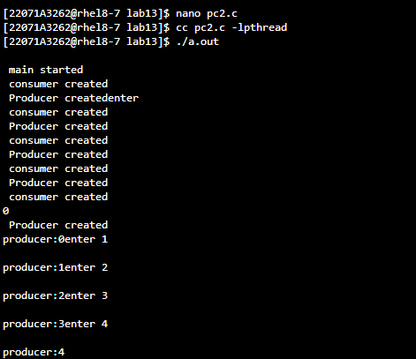

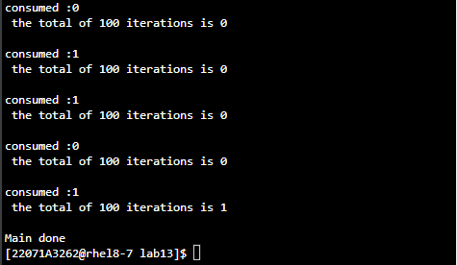

**Code for Dining Philosophers using semaphores:**

#include<stdio.h>  
#include<unistd.h>  
#include<semaphore.h>  
#include<pthread.h>  
  
sem_t room;  
sem_t chopstick[5];  
void *philosopher(void *);  
void eat(int);  
  
int main(){  
    int i,a[5];  
    pthread_t tid[5];  
    sem_init(&room,0,4);  
    for(i=0;i<5;i++){  
        sem_init(&chopstick[i],0,1);  
    }  
    for(i=0;i<5;i++){  
        a[i] = i;  
        pthread_create(&tid[i],NULL,philosopher,(void *)&a[i]);  
    }  
    for(i=0;i<5;i++)  
        pthread_join(tid[i],NULL);  
    return 0;  
}  
  
void *philosopher(void *num){  
    int phil = *(int *)num;  
    sem_wait(&room);  
    printf("\nPhilosopher %d has entered room",phil);  
    sem_wait(&chopstick[phil]);  
    sem_wait(&chopstick[(phil+1)%5]);  
    eat(phil);  
    sleep(2);  
    printf("\nPhilosopher %d has finished eating",phil);  
    sem_post(&chopstick[(phil+1)%5]);  
    sem_post(&chopstick[phil]);  
    sem_post(&room);  
}  
  
void eat(int phil){  
    printf("\nPhilosopher %d is eating",phil);  
}

**Output:**

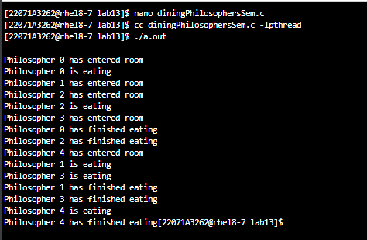

**Code for Dining Philosophers using monitors:**

#include<stdio.h>  
#include<pthread.h>  
#include<unistd.h>  
#define N 5  
pthread_mutex_t mutex;  
pthread_cond_t cond_var[N];  
enum {THINKING, HUNGRY, EATING} state[N];  
  
int left(int i){  
    return (i+N-1)&N;  
}  
  
int right(int i){  
    return (i+1)%N;  
}  
  
void test(int i){  
    if(state[i] == HUNGRY && state[left(i)] != EATING && state[right(i)] != EATING){  
        state[i] = EATING;  
        printf("Philosopher %d is eating\n",i);  
        pthread_cond_signal(&cond_var[i]);  
    }  
}  
  
void pickup_forks(int i){  
    pthread_mutex_lock(&mutex);  
    state[i] = HUNGRY;  
    printf("Philosopher %d is hungry\n",i);  
    test(i);  
    if(state[i] != EATING)  
        pthread_cond_wait(&cond_var[i],&mutex);  
    pthread_mutex_unlock(&mutex);  
}  
  
void return_forks(int i){  
    pthread_mutex_lock(&mutex);  
    state[i] =  THINKING;  
    printf("Philosopher %d is thinking\n",i);  
    test(left(i));  
    test(right(i));  
    pthread_mutex_unlock(&mutex);  
}  
  
void *philosopher(void *arg){  
    int *id = (int *)arg;  
    while(1){  
        usleep(1000000);  
        pickup_forks(*id);  
        usleep(1000000);  
        return_forks(*id);  
    }  
    return NULL;  
}  
  
int main(){  
    pthread_t tid[N];  
    int ids[N];  
    pthread_mutex_init(&mutex,NULL);  
    for(int i=0;i<N;i++){  
        pthread_cond_init(&cond_var[i],NULL);  
        ids[i] = i;  
        pthread_create(&tid[i],NULL,philosopher,&ids[i]);  
    }  
    for(int i=0;i<N;i++){  
        pthread_join(tid[i],NULL);  
    }  
    pthread_mutex_destroy(&mutex);  
    for(int i=0;i<N;i++){  
        pthread_cond_destroy(&cond_var[i]);  
    }  
    return 0;  
}

**Output:**

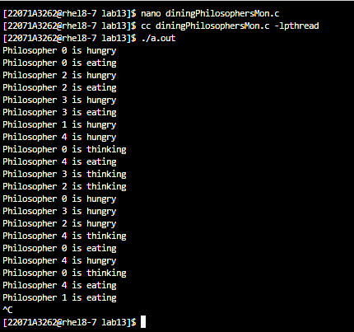

**Code for readers writers’ problem:**

**Output:**